App to App Authentication (A3)

1. In below, authentication style, during the boot up of application Application A, will receive all the application Id, a key to call Application B.
2. Application A generates a token, based on the Application B app id, Application A app Id and key of application B.
3. Application B validates the token with in itself by using DS, there is no network call is associated.
4. It can cause replay attack. Because Application A token will be static most of the time, unless server is restarted.

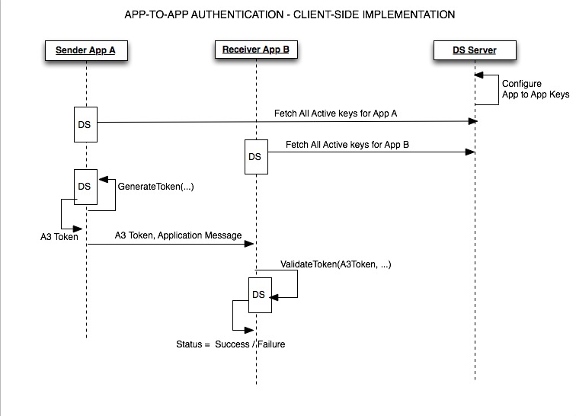

1. In the below authentication, the token is generated from DS Server every time, for each call with Application A to Application B.
2. It has network latency, but it avoids Replay attacks, because Token varies everytime.

